**REPORT ON ANOMALY DETECTION:**

After performing clustering for different number of clusters for each model, following observations can be made:

**Number of clusters: 3**

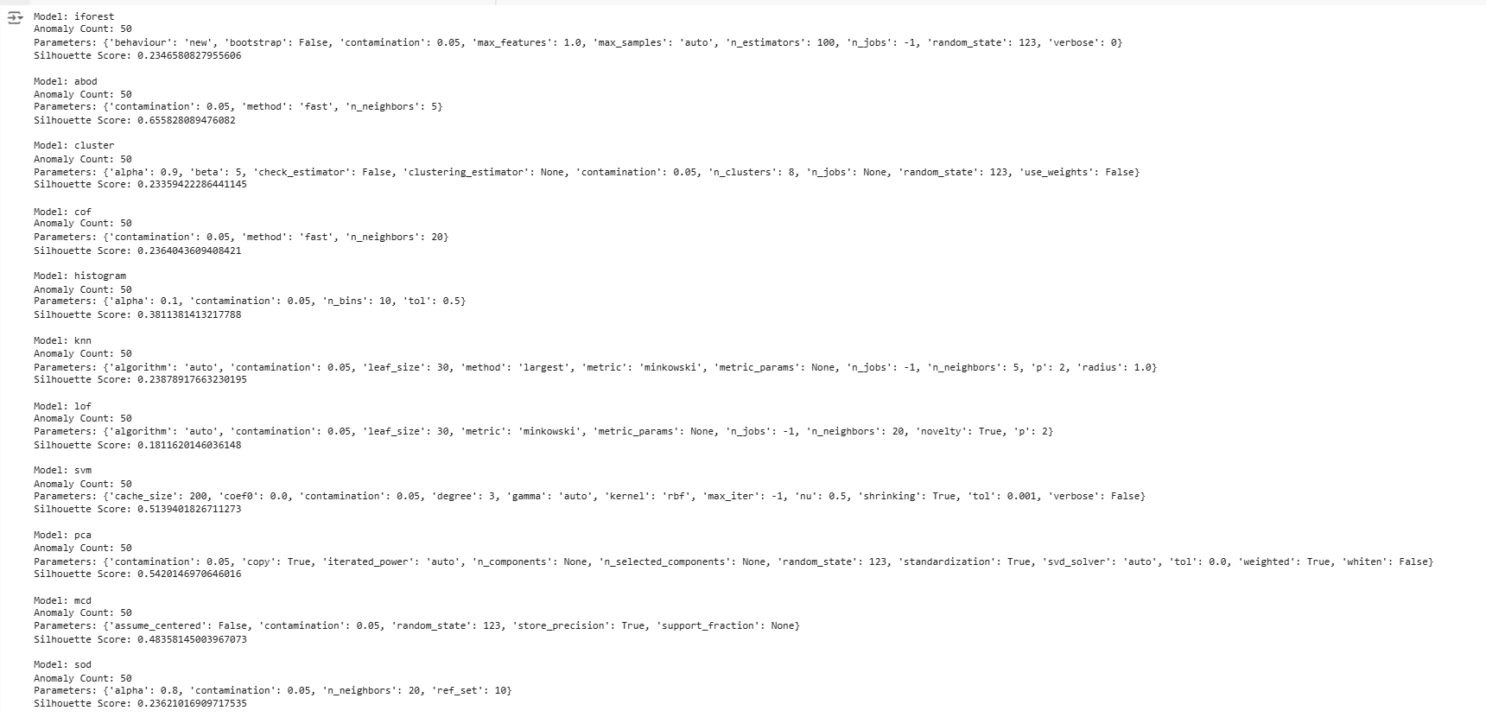

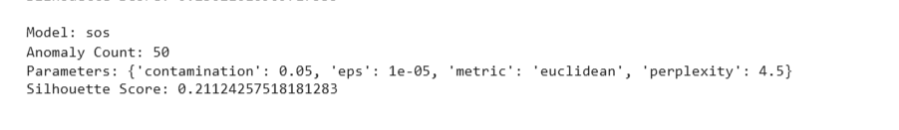

**Number of clusters: 4**

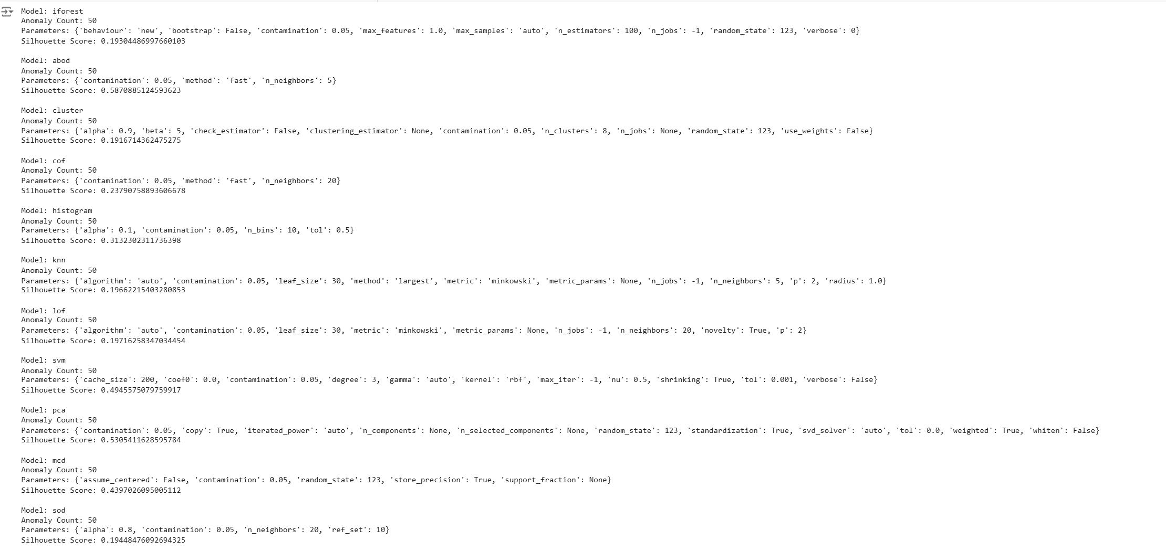

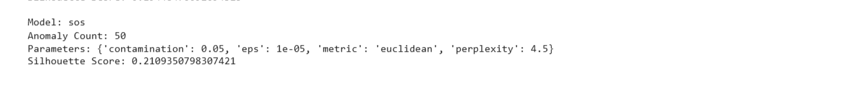

**Number of clusters: 5:**

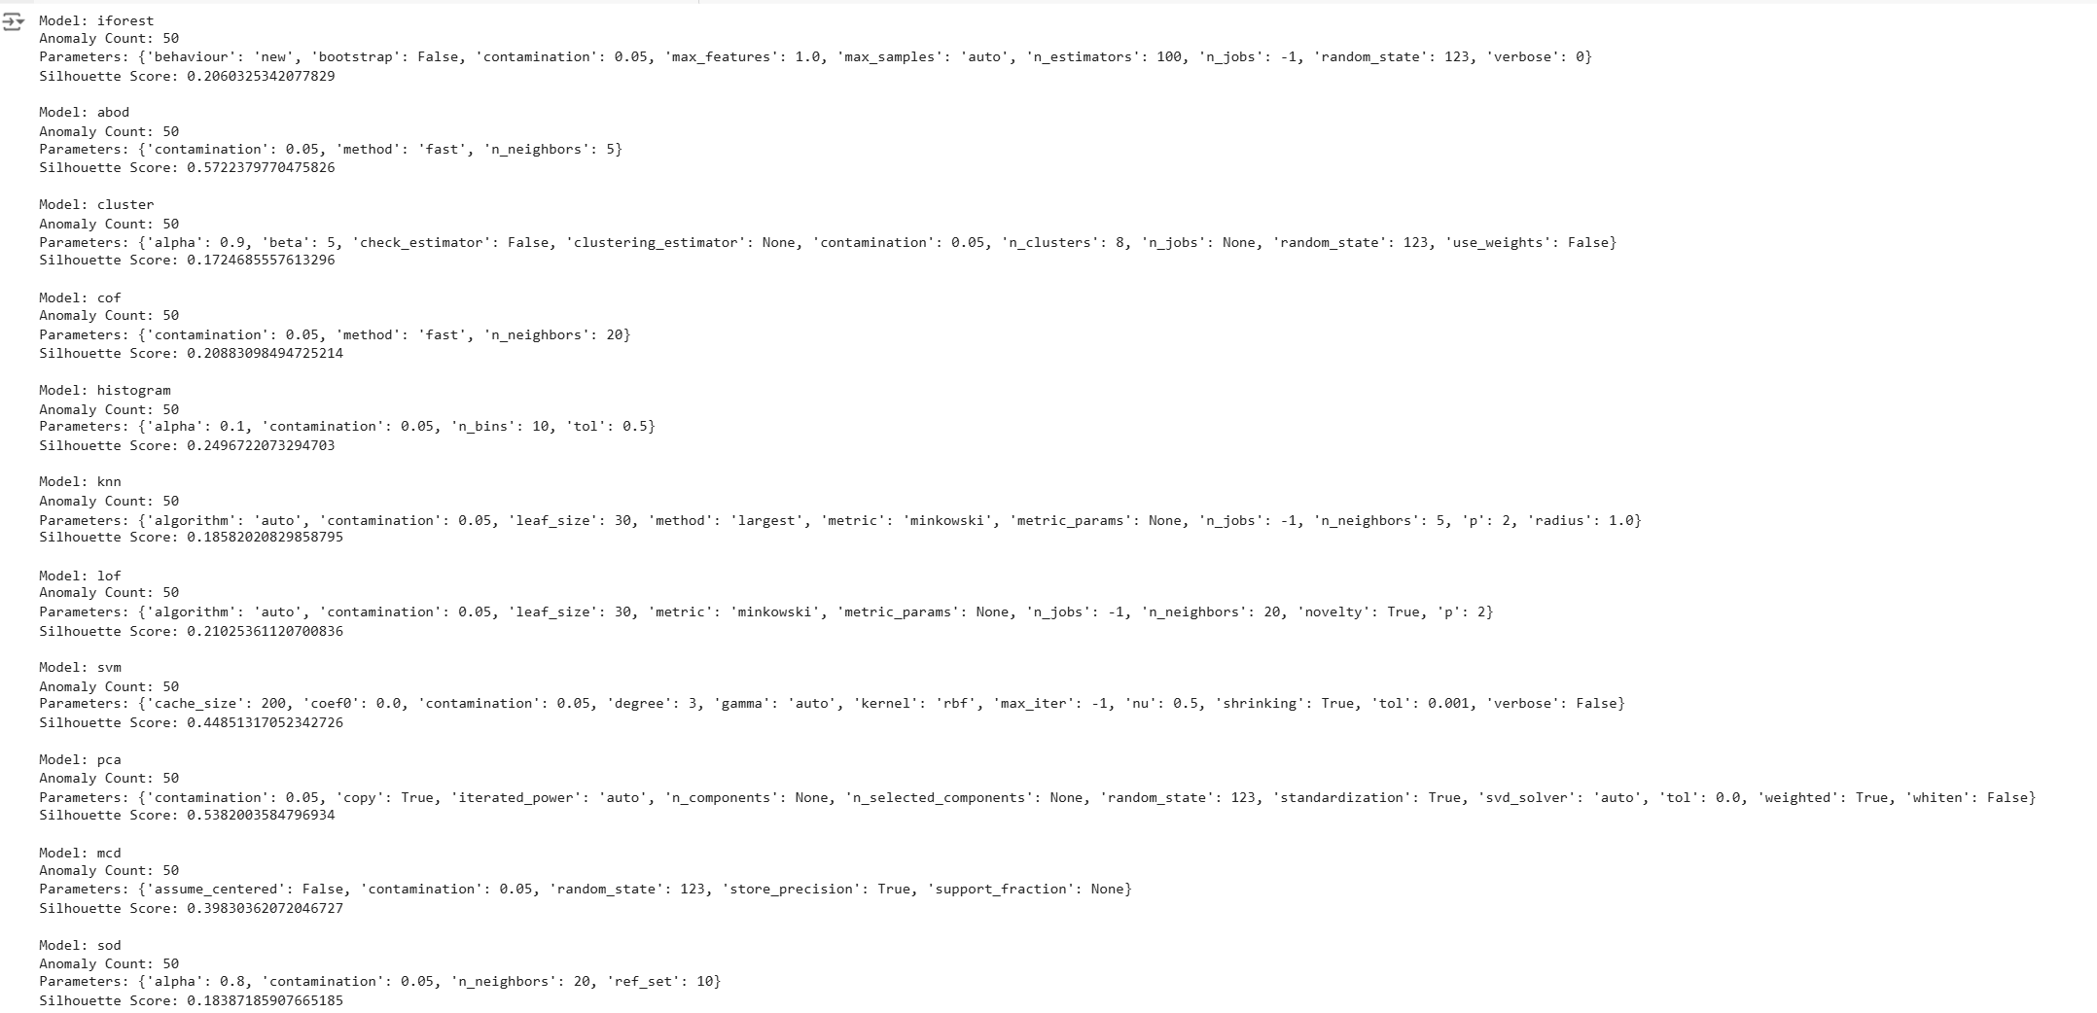

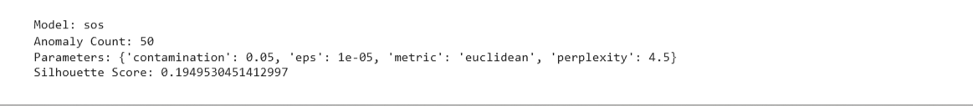

**Conclusion:**

|  |  |  |  |
| --- | --- | --- | --- |
| **Model** | **Anomaly Count** | **Number of clusters for max. score** | **Silhouette Score** |
| **Iforest** | **50** | **3** | **0.2346580827955606** |
| **Abod** | **50** | **3** | **0.655828089476082** |
| **Cluster** | **50** | **3** | **0.23359422286441145** |
| **Cof** | **50** | **4** | **0.23790758893606678** |
| **Histogram** | **50** | **3** | **0.3811381413217788** |
| **Knn** | **50** | **3** | **0.23878917663230195** |
| **Lof** | **50** | **5** | **0.21025361120700836** |
| **Svm** | **50** | **3** | **0.5139401826711273** |
| **Pca** | **50** | **3** | **0.5420146970646016** |
| **Mcd** | **50** | **3** | **0.48358145003967073** |
| **Sod** | **50** | **3** | **0.23621016909717535** |
| **Sos** | **50** | **3** | **0.21124257518181283** |